SAMPLE Contact Tracing Policy Covid 19 Pandemic

Purpose
The Facility is committed to following all State and Federal guidance and regulations to prevent the spread of Covid 19. The facility will work with local and regional health departments to help slow the spread of COVID-19. As per the CDC contact tracing and self-quarantining of people with COVID-19 and close contacts are critical to help slow transmission of COVID-19.

Procedure
The Facility will maintain a continuous log of every person, including staff and visitors, who may have close contact with other individuals at the Facility. This excludes EMS personnel and deliveries through contactless means outside of the facility.

  - Anyone entering the facility will be entered on facility log and screened including thermal screening for Covid 19.
  - Upon reopening of visitation all visitors will sign in and provide the following information on facility visitor log name, contact information including address, phone number, email address (if available) and date. An entry indicated the visitor passed the screening will also be logged.
  - The Administrator or his/her designee will maintain the log.
  - The log will be kept electronically via paper forms (appended) and a shared spreadsheet accessible by all staff within the building and remotely.
  - All visitors are provided with a visitor instruction sheet that is also posted in the facility informing visitors to report if the develop symptoms or are diagnosed with Covid 19 after visiting the facility.
  - The Infection Preventionist /designee will document information and contact Local Health Department immediately and follow all directives.
  - If a staff member, resident, or Consultant that visited the Facility reports testing positive for COVID-19, the Facility will immediately notify local health officials and follow all directives.
  - For a new onset of a positive Covid case for a resident or staff member the Infection Preventionist will document all contacts and conduct contact tracing utilizing facility Contact Tracing Form.
  - The facility reports all positive Covid cases via the NYS HERDS reporting and NHSN
  - The log will be used only to notify staff, visitors, and vendor consultants should an outbreak be identified at the Facility.
  - The Facility will maintain all individuals’ rights to the privacy of their health information and the confidentiality of Facility records.
https://www.cdc.gov/coronavirus/2019-ncov/php/contact-tracing/contact-tracing-plan/investigating-covid-19-case.html

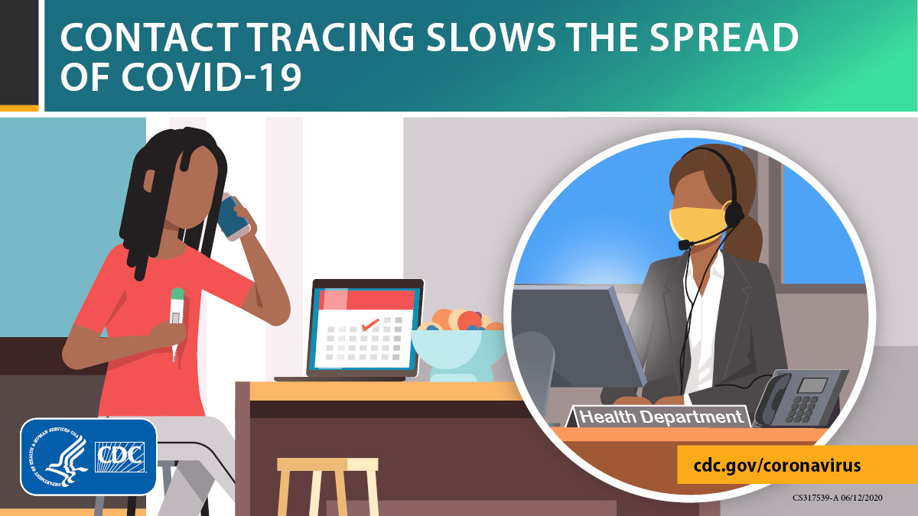

COVID 19 VISITOR CONTACT LOG
Employer Instructions: Maintain a continuous log of every person, including visitors, who may have close contact with other individuals at the work site or area, excluding deliveries that are performed with appropriate PPE or through contactless means

DATE | VISITOR NAME | PHONE NUMBER | EMAIL | PERSON(S) MEETING/VISITING | TIME IN | TIME OUT

