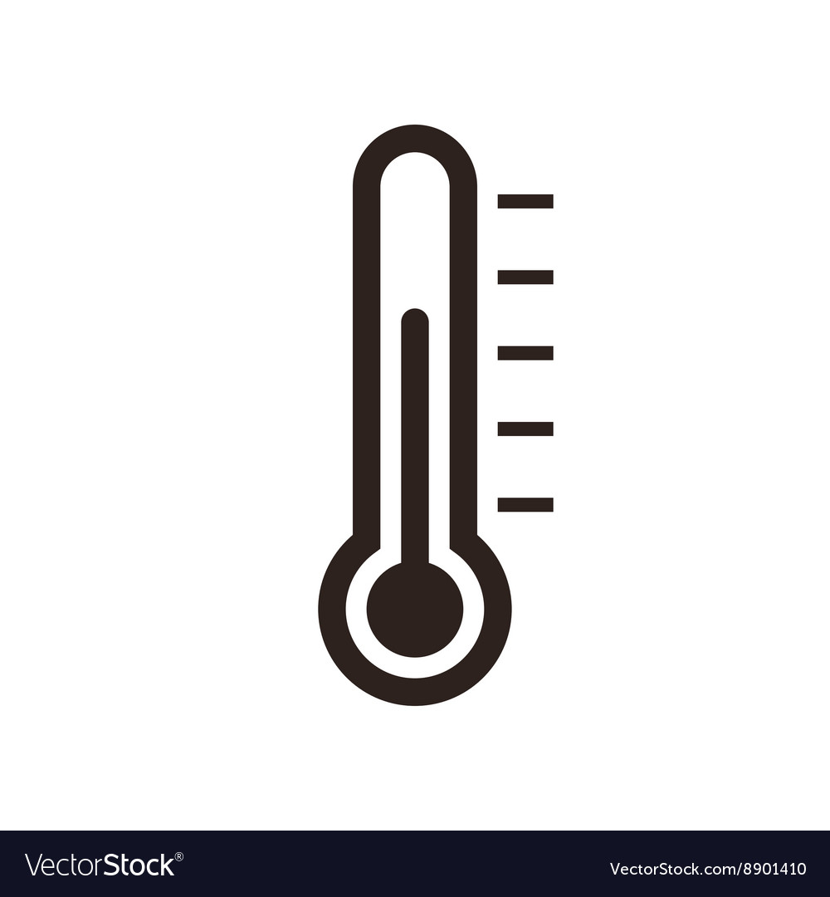



DATE: ___________

VISITATION GUIDANCE

VISITOR SAFETY FACT SHEET 8/29/2023
Covid+ Residents: ___________
Covid+ Staff: ___________
Flu+ Residents: ___________

- All visitors are strongly encouraged to adhere to the following best practices to reduce the risk of transmission of respiratory illnesses:
  - performing hand hygiene upon entering the building and before leaving the facility;
  - wearing a cloth mask or higher-level mask to cover mouth and nose at all times when the county’s transmission rate is substantial to high or as instructed by the facility;
  - wear gowns and gloves if indicated on signage on room door, while in resident rooms only.
  - remove gown and gloves and wash hands with soap and water or use alcohol-based hand sanitizer before leaving residents’ rooms.
- Visitors are encouraged to notify the facility (insert Department or contact person) if they experience any signs/symptoms consistent with respiratory illnesses, have been exposed to someone with Covid or tests positive for Covid within 48 hours of the visit.
- We respectfully encourage visitors to stay up to date with Covid, flu and RSV immunizations.
- While there is no limitation on the number of visitors a resident can receive, we respectfully ask that you limit the number of visitors in order to ensure social distancing rules are followed when Covid-19 community transmission rates are high.
- The facility may need to make accommodations for visiting to ensure safety of the roommate when visiting in a multi-resident room.
- While not recommended because of increased risk of getting Covid, residents who are on isolation precautions or quarantine can still receive visitors. Visits will be limited to the resident’s room.
- The following units are now under observation/precautions due to positive cases and/or exposure:
  - Insert unit(s)

