Infection Prevention and Control Policy and Procedure | Subject: Covid-19 Immunizations for Staff
Approved By:

Effective: 12/2020 | Reviewed/Revised: 4/21/2021; 5/5/2021; 6/2/2021; 8/18/2021; 8/25/2021; 8/27/2021; 9/23/2021; 10/6/2021; 10/21/2021; 12/29/2021; 1/6/2022; 1/27/2022; 2/24/2022; 5/25/2023

BACKGROUND
NYS regulatory requirement 10 NYCRR Section 2.61 (Prevention of Covid-19 Transmission by Covered Entities) requires healthcare personnel to be fully vaccinated against Covid-19. This law is being recommended for repeal by the NYS Department of Health subject to consideration by the Public Health and Health Planning Council (PHHPC). As per DAL 23-09, effective 5/24/2023, the NYSDOH will not cite providers for failing to comply with the requirements on 10 NYCRR Section 2.61 while the repeal is under consideration by the PHHPC. In CMS memo QSO-23-13-ALL, CMS announced that it will be ending the requirement for staff. To date, CMS guidance is pending. CMS and the Centers for Disease Control and Prevention (CDC) continue to recommend healthcare personnel (HCP) to stay up-to-date with the Covid-19 vaccine as recommended by the CDC.

POLICY:
To prevent the spread of infectious disease and to decrease the morbidity and mortality associated with the SARS-CoV-2 virus, commonly known as Covid-19, this facility will offer Covid-19 vaccine to all staff as recommended by the CDC and NYSDOH guidance. Staff members will be provided with education by a physician or licensed nurse regarding Covid-19 immunization. Any new vaccine information will be dispersed as they become available.

PROCEDURE
- Education will be provided to all staff of the facility, regarding the COVID-19 vaccination to include the mechanism of action, known efficacy, common side effects, and adverse reactions in accordance with information obtained from NYSDOH, CDC, ACIP, and the Emergency Use Authorization (EAU) Fact Sheet.
- Staff will be informed that all employees who have previously received monovalent vaccine doses are recommended to receive 1 bivalent mRNA vaccine dose as recommended by the CDC and NYSDOH unless they meet the criteria for a medical exemption.
- Medical: A documented history of a severe allergic reaction to any component of a COVID-19 vaccine or to a substance that is cross-reactive with a component; a documented history of a severe allergic reaction after a previous dose of the COVID-19 vaccine; physical condition/medical circumstance; other (medical provider will complete exemption form) https://www.cdc.gov/vaccines/covid-19/downloads/summary-interim-clinical-considerations.pdf
- Employees who seek an exemption will be required to submit a written request, to include the reason for seeking exemption.
- The medical exemption must be signed and dated by a licensed practitioner, who is not the same as the individual applying for the exemption, in accordance with all State and Local laws.
    - Documentation must include all information specifying which of the authorized Covid-19 vaccines are clinically contraindicated for the staff member to receive and the recognized clinical reasons for the contraindications. The licensed practitioner is also required to provide a statement recommending that the staff be exempted from the facility’s Covid-19 vaccination requirements for staff based on the recognized clinical contraindications.
- Request will be reviewed by the Infection Preventionist, Employee Health Coordinator, and the Medical Director to determine if reason(s) for exemption meet the requirements; a response will be provided within 14 days.
- At present, pending the repeal of the Covid-19 mandatory vaccination, (facility to insert what their current policy is on hiring unvaccinated personnel).
- At the discretion of the facility, employees who have not received at least a single dose of a Covid-19 vaccine, due to a medical exemption, will be required to get tested for Covid-19 at least once weekly.
- The facility will offer any recommended dose(s) of the covid vaccines to employees to align with ACIP and CDC’s recommendation as follows:
- Janssen (J&J) vaccine
    - Ages ≥18 years a single dose for primary vaccination series; a booster dose may be given at least 2 months after the primary dose.
- Moderna and Pfizer-BioNTech Vaccines (see table below)
  - * Monovalent Covid-19 vaccine products from Moderna and Pfizer are no longer recommended for use
  - Ages 12 years and older
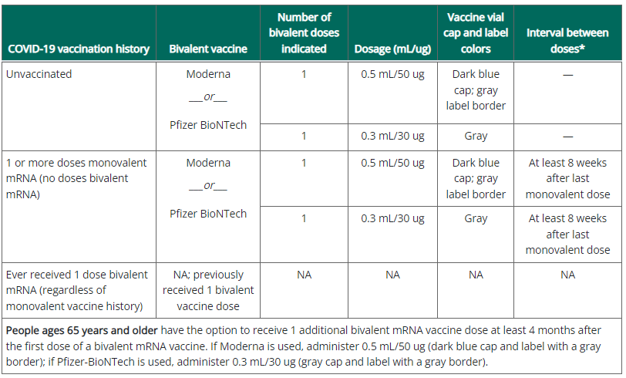

- Facility will track all staff wishing to receive the COVID-19 Vaccine at the facility and schedule a specific date and time to arrive at the Vaccine Clinic/dedicated area.

CONSENT/DECLINATIONS/EXEMPTIOMS
- The facility will utilize the COVID-19 vaccination consent form from NYS or partnering pharmacy.
- Staff members will be provided with a copy of the consent for review as well as a copy of the Emergency Use Authorization Fact Sheet for recipients COVID-19 Vaccination.
- When a staff member declines the COVID-19 Vaccination due to a medical exemption, a signed Covid-19 Vaccination Declination Form along with proof of exemption will be placed in the employee’s health folder.
- Staff member will be provided with education that it is his/her responsibility to request a Covid-19 vaccine should they now qualify for a Covid-19 vaccine and wish to receive it.
- The facility will post signage in high-trafficked areas throughout the building alerting staff that the facility offers Covid-19 vaccines and of vaccine clinic dates.
- Staff to notify Department Head or Designee of date they wish to be vaccinated.
- Staff may choose to get vaccinated in the community and present proof of same to facility.

VACCINE ADMINISTRATION
- Staff members will be assigned specific times for vaccine administration on the scheduled Vaccine Clinic days.
- Staff members presenting with the following conditions/symptoms will not be eligible to receive the COVID-19 Vaccination:
- Verbal report of feeling sick
- Exhibiting acute respiratory illness
- Diagnosed with COVID-19 and has not met the criteria for discontinuation of isolation precautions.
- Acute febrile condition with temperature above 100°F
- Other active infection
- Upon administration of Covid vaccine, the facility will complete all required reporting, including HERDS Survey, NYSIIS/CIR (as applicable) report, NHSN reporting.
- The staff member will be monitored following COVID-19 vaccination administration for a minimum of 15 minutes post vaccination in the designated area of the vaccine clinic.
- The facility will have readily available and accessible Epinephrine 1mg/1ml in the event of an anaphylactic/hypersensitivity reaction during vaccine administration.
- Staff members experiencing an anaphylactic reaction will be administered the Epi-pen by the Immunizer and 911 will be activated.
- Staff members will be provided with a Vaccination Card indicating the dates that the COVID Vaccine was administered.
- A copy of the COVID-19 Consent form and Vaccination Card will be placed in the employee health folder for each staff member.

POST VACCINATION MONITORING AND REPORTING
- Staff Members will be educated on common reactions post COVID-19 vaccination including injection site pain or redness or swelling, fatigue, headache, muscle pain, chills, fever, malaise.
- If a staff member develops any symptoms related to potential Covid 19 infection such as cough, shortness of breath or loss of taste or smell, they should be tested for Covid 19.
- Staff members will be educated to notify the facility immediately regarding any serious adverse reactions including:
- Cases of Multisystem Inflammatory Syndrome
- Cases of COVID-19 that result in hospitalization
- Cases of death following the administration of the COVID-19 Vaccination.
- Life threatening adverse event
- Inpatient hospitalization
- An important medical event that based on medical judgement of the PMD may jeopardize the individual and may require medical or surgical intervention to prevent outcomes listed above.
- The partnering pharmacy or the facility’s designated personnel will be responsible to enter vaccine information NYSIIS/CIR as applicable.
- In accordance with CMS QSO-21-19-NH, the facility will report Covid-19 vaccination data via NHSN at least weekly, the Covid-19 vaccination status of staff (and residents), total number of staff (and residents) vaccinated, each dose of vaccine received, and Covid-19 vaccination adverse events.
- The facility will communicate with the partner pharmacy (if applicable) when any of the mandatory adverse events are identified and assist with or report same on the Vaccine Adverse Event Reporting System. (VAERS@hhs.gov)
- The Covid-19 Vaccine may be given without regarding to timing of other vaccines providing there are no contraindications at the time of vaccination (CDC, 4/22/2023)
  - If multiple vaccines are administered at the same time, each injection will be administered at a different injection site.
- The facility will maintain a system for tracking Covid-19 vaccinations and medical exemptions. Tracking system will indicate which employees are facility staff, contracted staff, volunteers, or students (Survey Tag F888)

REFERENCES:
CDC. What To Expect After Getting a Covid-19 Vaccine. https://www.cdc.gov/coronavirus/2019-ncov/vaccines/pdfs/321466-A_FS_What_Expect_COVID-19_Vax_Final_12.13.20.pdf
NYSDOH (Effective 3/17/2021). Guidance for the NYS Covid Vaccination Program. https://coronavirus.health.ny.gov/system/files/documents/2021/03/guidance_for_facilities_receiving_vaccine.pdf
NYS (8/16/2021). Governor Cuomo Announces Covid-19 Vaccination Mandates for Healthcare Workers https://www.governor.ny.gov/news/governor-cuomo-announces-covid-19-vaccination-mandate-healthcare-workers
CMS (12/28/2021). QSO-22-07-ALL: Guidance for the Interim Final Rule – Medicare and Medicaid Programs; Omnibus Covid-19 Health Care Staff Vaccination. https://www.cms.gov/files/document/qso-22-07-all.pdf
FDA (3/13/2023). Fact Sheet for Recipients and Caregivers of EUA of the Janssen Covid-19 Vaccine to Prevent the Covid-19 Disease. https://www.fda.gov/media/146305/download
FDA (3/21/2023). Janssen Covid-19 Vaccine. https://www.fda.gov/emergency-preparedness-and-response/coronavirus-disease-2019-covid-19/janssen-covid-19-vaccine
FDA (4/18/2023). Fact Sheet for Recipients and Caregivers About Pfizer-BioNTech Covid-19 Vaccine, Bivalent Which has EUA to Prevent Covid-19. https://www.fda.gov/media/167212/download
FDA (4/18/2023). Fact Sheet for Recipients and Caregivers About Moderna Covid-19 Vaccine, Bivalent Which has EUA to Prevent Covid-19. https://www.fda.gov/media/167209/download
CDC (4/22/2023). Interim Clinical Considerations for Use of Covid-19 Vaccines Currently Authorized in the United States. https://www.cdc.gov/vaccines/covid-19/clinical-considerations/interim-considerations-us.html#recommendations
CMS (5/1/2023). QSO-23-13-ALL. Guidance for the Expiration of the Covid-19 Public Health Emergency (PHE). Guidance for the Expiration of the COVID-19 Public Health Emergency (PHE) (cms.gov)
CDC (5/8/2023). Interim Infection Prevention and Control Recommendations for Healthcare Personnel During the Coronavirus Disease 2019 Pandemic. Infection Control: Severe acute respiratory syndrome coronavirus 2 (SARS-CoV-2) | CDC.

NYSDOH (5/24/2023). DAL 23-09 Healthcare Worker Vaccine Mandate. Healthcare_worker_vaccine_mandate_guidance_final_1684955860079_0.pdf (ny.gov)

