Infection Control and Prevention Policy and Procedure | Subject: Return to Work After Exposure to or Covid-19 Infection
Approved by:

Effective: 8/12/2021 | Revised: 12/29/2021; 1/5/2022; 1/12/2022;  2/9/2022; 4/24/2022

POLICY
It is the policy of this facility to follow Centers for Disease Control and Prevention (CDC) and New York State Department of Health (NYSDOH) guidance to guide decision making about return to work for nursing home staff after a Covid-19 exposure or after a Covid-19 infection.

DEFINITIONS
Mild Illness: Individuals who have any of the various signs and symptoms of COVID 19 (e.g., fever, cough, sore throat, malaise, headache, muscle pain) without shortness of breath, dyspnea, or abnormal chest imaging.
Moderate Illness: Individuals who have evidence of lower respiratory disease by clinical assessment or imaging and a saturation of oxygen (SpO2) ≥94% on room air at sea level.
Severe Illness: Individuals who have respiratory frequency >30 breaths per minute, SpO2 <94% on room air at sea level (or, for patients with chronic hypoxemia, a decrease from baseline of >3%), ratio of arterial partial pressure of oxygen to fraction of inspired oxygen (PaO2/FiO2) <300 mmHg, or lung infiltrates >50%.
Critical Illness: Individuals who have respiratory failure, septic shock, and/or multiple organ dysfunction.
Severely Immunocompromised:
• Being on chemotherapy for cancer,
• Being within one year out from receiving a hematopoietic stem cell or solid organ transplant,
• Untreated HIV infection with CD4 T-lymphocyte count < 200,
• Combined primary immunodeficiency disorder, or
• Receipt of prednisone >20 mg/day for > 14 days.

Prolonged Close Contact: a cumulative time period of ≥15 minutes during a 24-hour period.

Fully Vaccinated: ≥2 weeks following receipt of the 2nd dose in a 2-dose series, or ≥2 weeks following receipt of 1 dose of a single-dose vaccine

Up to Date: a person has received all recommended Covid-19 vaccines, including any booster dose(s) when eligible.

Conventional Capacity Staffing Strategy: no staffing shortages
Contingency Capacity Staffing Strategy: when staffing shortages are anticipated
Crisis Capacity Staffing Strategy: when staffing shortages occur

PROCEDURE
- Facility QA Committee will assess staffing needs to determine if staffing needs are at the conventional, contingency or crisis levels to implement staffing plan.
  - If determined to meet criteria for crisis levels, facility will notify the department of health at the Surge and Flex Operations Center at 917-909-2676.
- The facility will utilize all DOH and CDC guidance to determine when employees can return to work after a Covid-19 infection or exposure.
  - Currently, the facility will utilize CDC’s Tables 1 and 2 below to determine when to allow employees to return to work after a Covid-19 exposure or infection based on the employees’ vaccination status, testing requirements as indicated, and the facility’s staffing needs.

TABLE 1: Managing Healthcare Personnel With SARS-CoV-2 Infection or Exposure

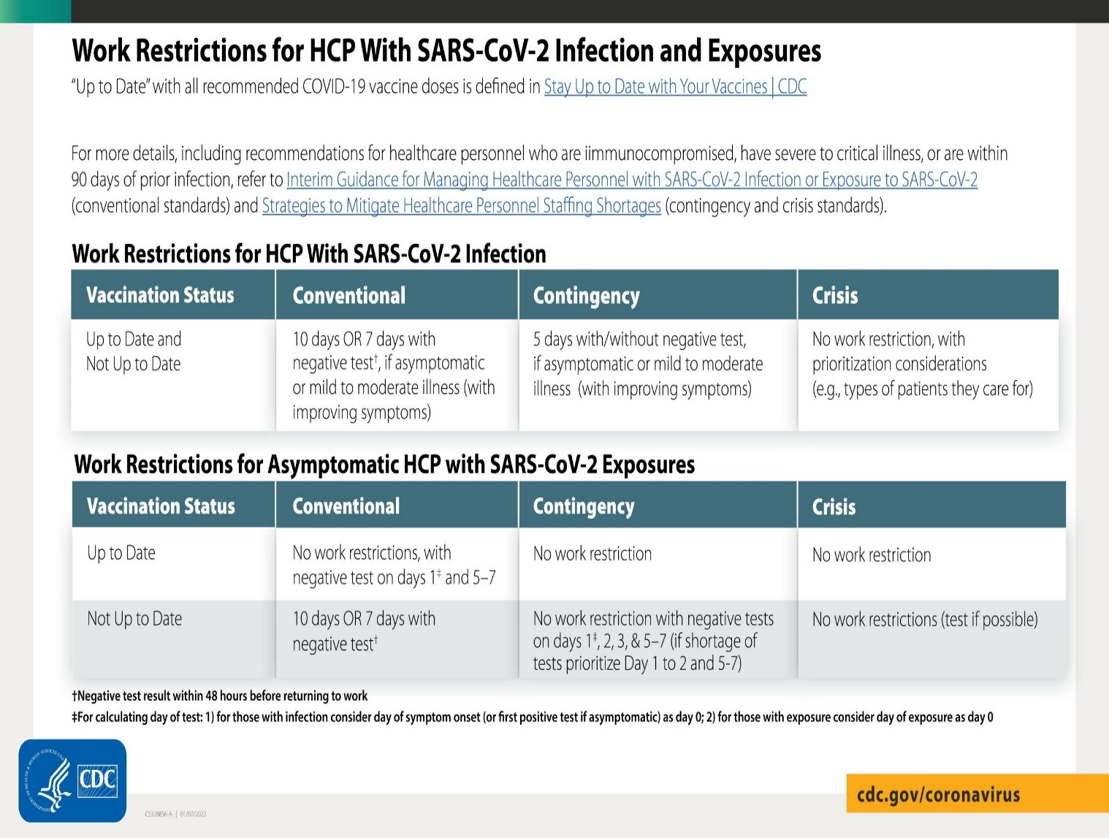
- The facility will utilize the symptom-based strategy (preferred) and/or the test-based strategy, as indicated, for return to work per CDC recommendation
- Symptom-Based Strategy:
- HCP with mild to moderate illness who are not severely immunocompromised:
  - At least 10 days have passed since symptoms first appeared and
  - At least 24 hours have passed since last fever without the use of fever-reducing medications and
  - Symptoms (e.g., cough, shortness of breath) have improved
- HCP who were asymptomatic throughout their infection and are not severely immunocompromised:
  - At least 10 days have passed since the date of their first positive viral diagnostic test.
- HCP with severe to critical illness or who are severely immunocompromised:
  - At least 10 days and up to 20 days have passed since symptoms first appeared and
  - At least 24 hours have passed since last fever without the use of fever-reducing medications and
  - Symptoms (e.g., cough, shortness of breath) have improved
  - May consider consultation with infection control expert
- Facility QA Committee will assess staffing needs to determine if staffing needs are at the conventional, contingency or crisis levels to implement emergency staffing plans.
  - Instances where the facility is facing critical staffing shortage, the facility will allow employees to return to work after day 5 of their isolation period (day zero = date of symptom onset if symptomatic OR date of collection of first positive if asymptomatic) if they meet the following criteria (CDC 1/21/2022):
    - The employee is fully vaccinated
    - The employee is asymptomatic, or, if they had mild symptoms, when they return to work, they must:
      - At least 24 hours have passed without the use of fever-reducing medication
      - Have resolution of symptoms or, if still with residual symptoms, then all are improving
    - The employee is able to consistently and correctly wear a well-fitting face mask, a higher-level mask such as a KN95, or a fit-tested N95 mask (cloth masks not permissible) while at work.
    - Individuals who are moderately to severely immunocompromised are not eligible to return to work under this guidance
- Test-Based Strategy:
- In some instances, a test-based strategy, in consultation with occupational health, may be considered to allow HCP to return to work earlier than if the symptom-based strategy were used (10 days without a test or 7 days with a test; day zero = date of symptom onset if symptomatic OR date of collection of first positive if asymptomatic).
- A test-based strategy may also be considered for some HCP (e.g., those who are severely immunocompromised) in consultation with local infectious diseases experts if concerns exist for the HCP being infectious for more than 20 days.
- Criteria for symptomatic staff
  - Resolution of fever without the use of fever-reducing medications and
  - Improvement in symptoms (e.g., cough, shortness of breath), and
  - Results are negative from at least two consecutive respiratory specimens collected ≥24 hours apart (total of two negative specimens) tested using an FDA-authorized laboratory-based NAAT to detect SARS-CoV-2 RNA
- Criteria for asymptomatic staff
  - Results are negative from at least two consecutive respiratory specimens collected ≥24 hours apart (total of two negative specimens) tested using an FDA-authorized laboratory-based NAAT to detect SARS-CoV-2 RNA

Return to Work Criteria after Domestic and International Travel
The facility will utilize CDC guidance to determine when an employee can return to work after travel
- Refer to https://www.cdc.gov/coronavirus/2019-ncov/travelers/index.html

REFERENCES

CDC (Updated 3/11/2021). Interim U.S. Guidance for Risk Assessment and Work Restrictions for Healthcare Personnel with Potential Exposure to SARS-CoV-2 https://www.cdc.gov/coronavirus/2019-ncov/hcp/guidance-risk-assesment-hcp.html

NYSDOH (4/1/2021). Updated Interim Guidance for Travelers Arriving in New York State.

CDC (Updated 6/2/2021). Return to Work Criteria for Healthcare Personnel with SARS-CoV-2 Infection (Interim Guidance). https://www.cdc.gov/coronavirus/2019-ncov/hcp/return-to-work.html

NYSDOH (8/6/2021) Revised Advisory Nursing Home Cohorting FAQs https://commerce.health.state.ny.us/hpn/ctrldocs/alrtview/postings/DOH_COVID19_NursingHomeCohortingFAQs_080621_1628284901536_0.pdf

NYSDOH (12/24/2021). Advisory on Shortening Isolation Period for Certain Fully Vaccinated Healthcare Workers and Other Critical Workforce. https://apps.health.ny.gov/pub/ctrldocs/alrtview/postings/Return_to_Work_Isolation_Guidance_12-24-21_1640373876572_0.pdf

CDC (12/23/2021). Interim Guidance for Managing Healthcare Personnel with SARS-CoV-2 Infection or Exposure to SARS-CoV-2. https://www.cdc.gov/coronavirus/2019-ncov/hcp/guidance-risk-assesment-hcp.html

CDC (12/23/2021). Strategies to Mitigate Healthcare Personnel Staffing Shortages. https://www.cdc.gov/coronavirus/2019-ncov/hcp/mitigating-staff-shortages.html

NYSDOH (1/4/2022). Interim Advisory on Return-To-Work Protocols for Personnel with SARS-CoV-2 Infection or Exposure to SARS-CoV-2 in Healthcare Settings. https://apps.health.ny.gov/pub/ctrldocs/alrtview/postings/NYS_Updated_Isolation_and_Quarantine_Guidance_01042022_1641333320555_0.pdf

CDC (1/21/2022). Interim Guidance for Managing Healthcare Personnel with SARS-CoV-2 Infection or Exposure to SARS-CoV-2. https://www.cdc.gov/coronavirus/2019-ncov/hcp/guidance-risk-assesment-hcp.html

NYSDOH (2/4/2022). Updated Advisory on Return-to-Work Protocols for Healthcare Personnel with SARS-CoV-2 Infection or Exposure to SARS-CoV-2. https://apps.health.ny.gov/pub/ctrldocs/alrtview/postings/HCP_RTW_Guidance_Matrix_Update_2042022_1644019024427_0.pdf

