Infection Prevention and Control Policy and Procedure | Subject: Covid-19 Immunizations for Residents
Approved By:

Effective: 12/2020 | Reviewed/Revised: 4/21/2021; 5/5/2021; 6/2/2021; 8/25/2021; 9/23/2021; 10/6/2021; 10/21/2021; 1/6/2022; 1/26/2022; 4/19/2022; 6/22/2022; 9/21/2022; 4/25/2023

BACKGROUND
SARS-CoV-2, commonly known as COVID-19, is primarily a viral respiratory infection. It is most commonly spread between people who are in close proximity of each other (within 6 feet). It spreads through respiratory droplets or small particles produced when an infected person coughs, sneezes, sings, talks or breathes. These particles can be inhaled into the nose and mouth, and eventually into the lungs, causing an infection. Droplets can also land on surfaces and inanimate objects and spread when dirty hands touch the eyes, nose and mouth. The incubation period is between 2-14 days. Symptoms of the virus include fever, cough, shortness of breath, severe lower respiratory infection/acute respiratory distress syndrome and may also include nasal congestion, sore throat, diarrhea, and nausea. The potential for more serious illness among older adults, coupled with the more closed, communal nature of the nursing home environment, represents a risk of outbreak and a substantial challenge for nursing homes.

POLICY
To prevent the spread of infectious disease and to decrease the morbidity and mortality associated with the SARS-CoV-2 virus, commonly known as Covid-19, this facility will offer Covid-19 immunization(s) for all residents in accordance with the Center for Disease Control and Epidemiology’s (CDC) eligibility recommendations.

PROCEDURE
- Upon admission or re-admission, residents will be assessed for eligibility to receive either the Janssen, Moderna or Pfizer-BioNTech Covid-19 vaccine, and when indicated, will be offered the vaccine within fourteen (14) days of admission to the facility, unless medically contraindicated or the resident has already received CDC’s recommended dose(s).
- Before receiving any of the Covid-19 vaccines, the resident and/or healthcare representative will be provided with information and education regarding the benefits and potential side effects of the specific vaccine to be received utilizing the Emergency Use Authorization (EUA) Fact Sheet for Recipients and Caregivers.
- For situations in which a resident lacks capacity to make healthcare decisions and there is no next of kin or designated healthcare representative, a risk vs. benefit analysis will be done, and a two-physician consent/declination will be required.
- Consent/declination for Covid-19 immunization forms will be kept in resident’s chart (electronic or hard-copy) and will be documented in the Immunization Care Plan.
- The vaccine will not be offered or administered to residents with contraindications:
- History of severe allergic reaction after a previous dose of the vaccine
- History of severe allergic reaction to any ingredient of the vaccine
- Residents with acute Covid-19 infection and still under isolation (can be vaccinated after resolution of infection).
- Residents who refuse Covid-19 immunizations will be re-offered at each care plan meeting, if applicable.
- The facility will adhere to the following vaccination schedule per CDC recommendations:
  - Janssen (J&J) vaccine
    - Ages ≥18 years a single dose for primary vaccination series; a booster dose may be given at least 2 months after the primary dose.
- Moderna and Pfizer-BioNTech Vaccines (see table below)
  - * Monovalent Covid-19 vaccine products from Moderna and Pfizer are no longer recommended for use
  - Ages 12 years and older
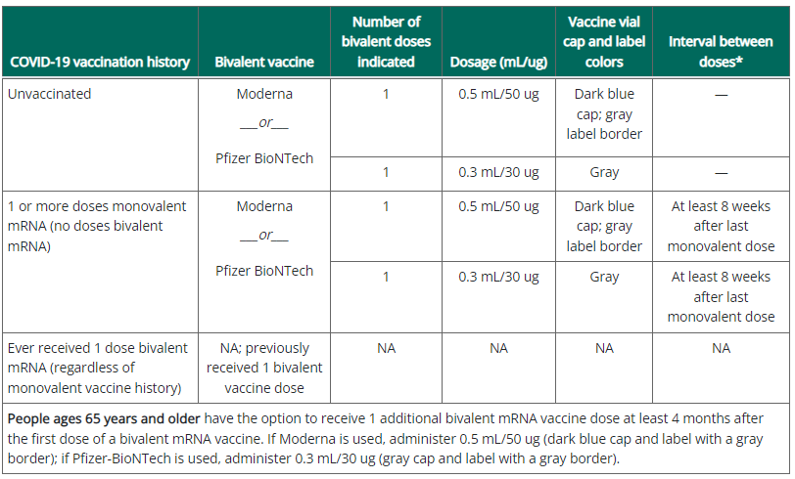
- A licensed nurse will administer the vaccine as ordered and document administration on the electronic Medication Administration Record (MAR).
  - Documentation will include name of vaccine, manufacturer information, lot #, expiration date, site, and date of administration.
  - The charge nurse/unit manager is responsible for updating the immunization record on the chart screen (acceptance/declination) and the immunization care plan (acceptance/declination).
- After administration, assigned nursing staff will monitor the resident closely x 15minutes after administration and then every shift x 72 hours for potential side/adverse effects of the vaccine.
- If a resident has a history of anaphylaxis they will be monitored after immunization for 30 minutes.
- Potential side effects following Covid-19 vaccine that have been reported include injection site pain, fatigue, headache, muscle pain, chills, joint pain, fever, injection site swelling, injection site redness, nausea, malaise, and lymphadenopathy.
- If a resident experiences post vaccination signs/symptom, as outlined above, PMD/NP/RN will assess resident to determine if any treatment or follow up is needed.
- Should resident develop acute distress, a “Code Blue” will be initiated, and EMS system will be activated immediately to transfer resident to an acute care setting as needed.
- Epinephrine will be available in the facility’s emergency box(es) and in immunization area(s) for utilization in the event of severe allergic reactions.
- Any side/adverse effects will be documented in the medical record with MD notification and Vaccine Adverse Event Reporting System (VAERS) follow up documentation. The vaccination administrator is responsible for MANDATORY reporting of reportable events that include
- Vaccine administration errors whether associated with an adverse event
- Serious adverse events* (irrespective of attribution to vaccination)
- Cases of Multisystem Inflammatory Syndrome (MIS) in children and adults
- Cases of COVID-19 that result in hospitalization or death
- Vaccine information will be entered into the Citywide Immunization Registry (CIR) or NYS Immunization Information System (NYSIIS) as applicable, either by the facility or the vendor pharmacy (per facility protocol) within 24 hours of vaccine administration.
- In accordance with CMS QSO-21-19-NH, the facility will report Covid-19 vaccination data via NHSN (Survey Tag F884) at least weekly, the Covid-19 vaccination status of residents (and staff), total number of residents (and staff) vaccinated, each dose of vaccine received, Covid-19 vaccination adverse events, and therapeutics administered to residents for treatment of Covid-19.
- Administration of the vaccine will be deferred in residents with acute respiratory disease, active infection, or acute febrile illness until resident has recovered.
  - Vaccination will be deferred for residents with known SARS-CoV-2 infection at least until recovery from acute illness (if symptoms were present) and criteria to discontinue isolation have been met (CDC 4/22/2023).
- The Covid-19 Vaccine may be given without regarding to timing of other vaccines providing there are no contraindications at the time of vaccination (CDC 4/22/2023).
  - If multiple vaccines are administered at the same time, each injection will be administered at a different injection site.
- The facility will track consents, declinations, and vaccinations for all residents.
- Residents who declined Covid-19 vaccine will be provided with education that they can request a Covid-19 vaccine at any time should they change their mind.

REFERENCES
CDC (Updated 12/13/2020). Post Vaccine Considerations for Residents. https://www.cdc.gov/coronavirus/2019-ncov/hcp/post-vaccine-considerations-residents.html
CMS (5/11/2021). Interim Final Rule – COVID-19 Vaccine Immunization Requirements for Residents and Staff. https://www.cms.gov/files/document/qso-21-19-nh.pdf
FDA (3/13/2023). Fact Sheet for HCP Administering EUA of the Janssen Covid-19 Vaccine to Prevent the Covid-19 Disease. https://www.fda.gov/media/146304/download
FDA (3/13/2023). Fact Sheet for Recipients and Caregivers of EUA of the Janssen Covid-19 Vaccine to Prevent the Covid-19 Disease. https://www.fda.gov/media/146305/download
FDA (3/21/2023). Janssen Covid-19 Vaccine. https://www.fda.gov/emergency-preparedness-and-response/coronavirus-disease-2019-covid-19/janssen-covid-19-vaccine
FDA (4/18/2023). Fact Sheet for HCP Administering Vaccine: EUA of Moderna Covid-19 Vaccine, Bivalent (Original and Omicron BA.4/BA.5). https://www.fda.gov/media/167208/download
FDA (4/18/2023). Fact Sheet for HCP Administering Vaccine: EUA of Pfizer-BioNTech Covid-19 Vaccine, Bivalent (Original and Omicron BA.4/BA.5). https://www.fda.gov/media/167211/download
FDA (4/18/2023). Fact Sheet for Recipients and Caregivers About Pfizer-BioNTech Covid-19 Vaccine, Bivalent Which has EUA to Prevent Covid-19. https://www.fda.gov/media/167212/download
FDA (4/18/2023). Fact Sheet for Recipients and Caregivers About Moderna Covid-19 Vaccine, Bivalent Which has EUA to Prevent Covid-19. https://www.fda.gov/media/167209/download
CDC (4/22/2023). Interim Clinical Considerations for Use of Covid-19 Vaccines Currently Authorized in the United States. https://www.cdc.gov/vaccines/covid-19/clinical-considerations/interim-considerations-us.html#recommendations

