POLICY:
To prevent the spread of infectious disease and to decrease the morbidity and mortality associated with the SARS-CoV-2 virus, commonly known as Covid-19, this facility will offer Covid-19 vaccine to all staff. Staff members will be provided with education by physician or licensed nurse regarding Covid-19 immunization using the Emergency Authorization Use (EAU) Fact Sheets for Health Care Professionals and the Vaccine Information Statements (VIS). Any new vaccine information will be dispersed as they become available. Per Section 16 of the NYS Public Health Law, Long Term Care Facility employees are required to be vaccinated with at least one dose of a Covid-19 vaccine by September 27, 2021.

PROCEDURE
EDUCATION
- Education will be provided to all staff of the facility, regarding the COVID-19 vaccination to include the mechanism of action, known efficacy, common side effects, and adverse reactions in accordance with information obtained from NYSDOH, CDC, ACIP, and the Emergency Use Authorization (EAU) Fact Sheet and the VIS. The Education will include:
- The significant known and potential risks and benefits of the COVID-19 vaccine, and the extent to which such risks and benefits are unknown.
- Letters containing informational material
- Handouts from Vaccination Pharmacy providers
- CDC/NYS DOH handouts to include fact sheets, signage, and FAQ’s
- Emergency Use Authorization Fact Sheet for Recipients and the VIS
- Staff will be informed that all employees are required to have at least 1 dose of a Covid-19 vaccine by September 27,2021, unless they meet the criteria for religious or medical exemption
  - Exemptions include limited religious and medical reasons
    - Religious: A religious exemption may be granted if the individual holds genuine and sincere religious belief, observance, or practice that are contrary to the practice of immunization
    - Medical: A documented history of a severe allergic reaction to any component of a COVID-19 vaccine or to a substance that is cross-reactive with a component; a documented history of a severe allergic reaction after a previous dose of the COVID-19 vaccine; physical condition/medical circumstance; other (medical provider will complete exemption form)
- Employees who seek exemption will be required to submit a written request for exemption, to include reason for seeking exemption. Request will be reviewed by the Quality Assurance Committee to determine if reason(s) for exemption meet American Disabilities Act (ADA) and/or Equal Employment Opportunity Commission (EEOC) guidelines. A response will be provided within 14 days.
- Prospective employees will be provided with education that at least 1 dose of a Covid-19 vaccine is required before they can start working at the facility prior to September 27, 2021 (unless has documentation with proof of exemption)
- Employees who have not received at least a single dose of a Covid-19 vaccine, due to a religious or medical exemption, will be required to get tested for Covid-19 once weekly if working on-site ≤3 days per week or twice weekly if working ≥4 days per week (facility to insert parameter)
  - Failure to comply will result in removal from schedule until such time that staff member presents proof of Covid-19 test
  - (facility may establish additional accommodations with regards to PPEs)
- The facility will offer a booster dose of the Pfizer vaccine at least 6 months after receipt of the 2nd shot in the primary series to all staff who previously received the Pfizer vaccine and has consented to receiving the booster dose, in alignment with ACIP’s 9/24/2021 recommendation (at this time, booster dose for Moderna and J&J vaccines under review).
  - Booster doses are offered based on the following criteria:
    - People aged 18-64 years who are at increased risk for Covid-19 exposure and transmission because of occupational or institutional setting (e.g. nursing home employees)
- The facility will inform Staff Members when any new information is released from the above agencies regarding the COVID-19 vaccine including any new vaccines available and other potential locations to receive Covid 19 vaccination.
- Facility will track all Staff Members wishing to receive the COVID-19 Vaccine and schedule a specific date and time to arrive at the Vaccine Clinic/dedicated area. The facility will provide community vaccination site information upon request
- The facility will assign a “point of contact” or designee for providing information on how staff are educated about and offered the Covid-19 vaccines, including samples of educational materials.

CONSENT/DECLINATIONS/EXEMPTIOMS
- The facility will utilize the COVID-19 vaccination consent form from NYS or partnering pharmacy
- Staff members will be provided with a copy of the consent for review as well as a copy of the Emergency Use Authorization Fact Sheet for recipients COVID-19 Vaccination.
- When a staff member declines the COVID-19 Vaccination due to a medical exemption, a signed Covid-19 Vaccination Declination Form along with proof of exemption will be placed in the employee’s health folder.
- Staff member will be provided with education that it is his/her responsibility to request a Covid-19 vaccine should they now qualify for a Covid-19 vaccine and wish to receive it
- The facility will post signage in high-trafficked areas throughout the building alerting staff that the facility offers Covid-19 vaccines and of vaccine clinic dates
- Staff to notify Department Head or Designee of date they wish to be vaccinated based on clinic dates
- Staff may choose to get vaccinated in the community and present proof of same to facility

VACCINE ADMINISTRATION
- Staff members will be assigned specific times for vaccine administration on the scheduled Vaccine Clinic days.
- Staff members presenting with the following conditions/symptoms will not be eligible to receive the COVID-19 Vaccination:
- Verbal report of feeling sick
- Exhibiting acute respiratory illness
- Diagnosed with COVID -19 within the last 14 days
- Acute febrile condition with temperature above 100°F
- Other active infection
- The COVID-19 Vaccination Clinic will be set up as per the Pharmacy, in conjunction with facility guidelines, including adequate space for physical distancing, and an area for post vaccination monitoring
- Staff identification will be verified by name and date of birth.
- Staff member’s temperature will be taken and recorded prior to vaccination
- At the time of the vaccination the staff member will inform Immunizer regarding the following:
- Restrictions for injections on specified arm due to surgery
- Presence of AV shunt
- The immunizer will administer the vaccine as per Emergency Authorization Use Protocol and the VIS
- Should the facility be administering the vaccine (designated vaccinator), transportation, storage, handling, and preparation of the vaccine will be adhered to in collaboration with the pharmacy partner and in accordance with the specific Covid vaccine recommendations for approved Covid vaccines.
- The facility will complete all required reporting, including the Vaccine Tracker, HERDS Survey, and NYSIIS/CIR (as applicable)
  - In stances when syringes will be pre-filled/pre-drawn:
    - A dedicated area will be utilized for vaccine preparation
    - Each vaccine type will be labeled to prevent medication error
    - Pre-filled/Pre-drawn syringes will be stored at the manufacturer recommended temperatures throughout the day
      - Administration of Pfizer Covid-19 vaccine (Comirnaty) within six (6) hours of dilution.
      - Administration of Moderna vaccine within 12 hours of initial vial puncture.
      - Administration of Janssen vaccine within two (2) hours of initial vial puncture if vaccine is stored at room temperature OR within six (6) hours of initial vial puncture if vaccine is refrigerated at all times other than while preparing, drawing up and administering the vaccine.
- The facility will maintain a list of “standby” eligible individuals to be notified for open appointments for vaccine administration on short notice.
- The Staff Member will be monitored following COVID-19 vaccination administration for a minimum of 15 minutes post vaccination in the designated area of the Vaccine Clinic.
- The facility will have readily available and accessible Epinephrine 1mg/1ml in the event of an anaphylactic/hypersensitivity reaction during vaccine administration.
- Staff Members experiencing an anaphylactic reaction will be administered the Epi-pen by the Immunizer and 911 will be activated.
- Staff Members will be provided with a Vaccination Card indicating the dates that the COVID Vaccine was administered
- A copy of the COVID-19 Consent form and Vaccination Card will be placed in the employee health folder for each staff member.

POST VACCINATION MONITORING AND REPORTING
- Staff Members will be educated on common reactions post COVID-19 vaccination
- Injection site pain, redness or swelling
- Fatigue
- Headache
- Muscle pain
- Chills
- Fever
- Nausea
- Malaise
- If a staff member develops any symptoms related to potential Covid 19 infection such as cough, shortness of breath or loss of taste or smell, they should be tested for Covid 19.
- Staff members will be educated to notify the facility immediately regarding any serious adverse reactions including:
- Cases of Multisystem Inflammatory Syndrome
- Cases of COVID-19 that result in hospitalization
- Cases of death following the administration of the COVID-19 Vaccination.
- Life threatening adverse event
- Inpatient hospitalization
- An important medical event that based on medical judgement of the PMD may jeopardize the individual and may require medical or surgical intervention to prevent outcomes listed above
- The partnering pharmacy or the facility’s designated personnel will be responsible to enter vaccine information NYSIIS/CIR as applicable
- In accordance with CMS QSO-21-19-NH, the facility will report Covid-19 vaccination data via NHSN (Survey Tag F884)
- The facility will communicate with the partner pharmacy (if applicable) when any of the mandatory adverse events are identified and assist with or report same on the Vaccine Adverse Event Reporting System. (VAERS@hhs.gov)
- The Covid-19 Vaccine may be given without regarding to timing of other vaccines as ordered by a Physician (CDC, 5/14/2021)
  - If multiple vaccines are administered at the same time, each injection will be administered at a different injection site.
- Staff Members will be provided with immunization card including date for 2nd vaccine administration schedule as applicable.
- If a Staff Member resigns after receiving the first dose of the two-part COVID-19 vaccine (applicable to Pfizer and Moderna vaccines), they will be requested to return to the facility or go to a vaccination site in the community on the set date to receive the second dose.
- If it is not feasible to adhere to the recommended interval and a delay in vaccination is unavoidable, the 2nd dose of the Pfizer and Moderna Covid Vaccines may be administered up to 6 weeks (42 days) after the first dose.
- Janssen Vaccine is a one dose only (Johnson and Johnson)
- Covid vaccines are not interchangeable; therefore, if a 2-dose series vaccine is used, the second dose will be the same as the first.
- The Facility will track staff Covid 19 immunization history on employee health assessment/physicals as needed

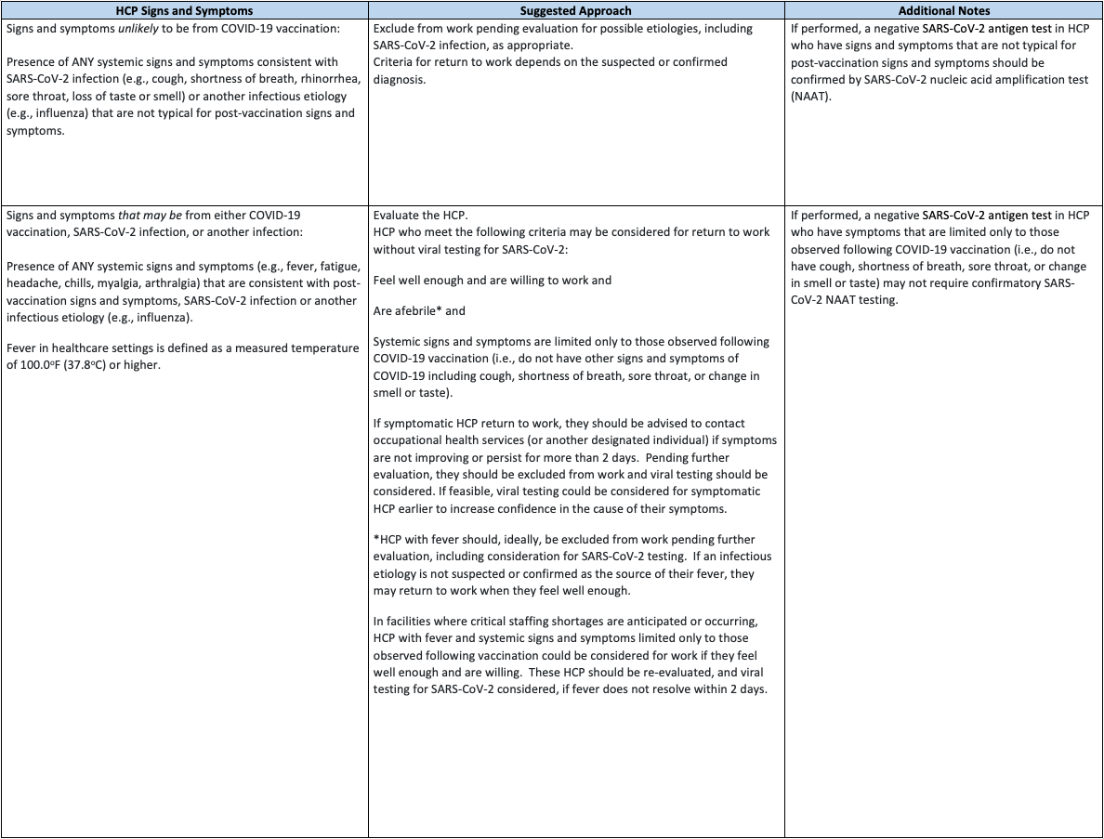

REFERENCES:
CDC (Updated 12/13/2020). Post Vaccine Considerations for Residents. https://www.cdc.gov/coronavirus/2019-ncov/hcp/post-vaccine-considerations-residents.html
CDC. What To Expect After Getting a Covid-19 Vaccine. https://www.cdc.gov/coronavirus/2019-ncov/vaccines/pdfs/321466-A_FS_What_Expect_COVID-19_Vax_Final_12.13.20.pdf
CDC (12/21/2020). Covid-19 Vaccination Communication Toolkit. https://www.cdc.gov/vaccines/covid-19/health-systems-communication-toolkit.html
CDC (Updated 3/5/2021). Interim Clinical Considerations for Use of Covid-19 Vaccines Currently Authorized in the United States. https://www.cdc.gov/vaccines/covid-19/info-by-product/clinical-considerations.html#Administration
NYSDOH (Effective 3/17/2021). Guidance for the NYS Covid Vaccination Program. https://coronavirus.health.ny.gov/system/files/documents/2021/03/guidance_for_facilities_receiving_vaccine.pdf
Moderna https://www.modernatx.com/covid19vaccine-eua/providers/
Pfizer (12/2020). Fact Sheet for Healthcare Providers Administering Vaccines (Vaccination Providers). https://www.fda.gov/media/144413/download
Pfizer (12/2020). Fact Sheet for Recipients and Caregivers. https://www.fda.gov/media/144414/download
FDA (Rev 4/23/2021). EUA of Janssen Covid-19 Vaccine to Prevent Covid-19 in Individuals 18 Years of Age and Older. https://www.fda.gov/media/146305/download
NYSDOH DAL (4/19/2021). https://commerce.health.state.ny.us/HCSRestServices/HCSContentServices/docs?docPath=/hcs_Documents/Source/hpn/hpnSrc/C05AC5D9214C5A0AE0530547A8C08215.pdf
NYSDOH (5/3/2021). Covid-19 Policy for Predrawn Vaccine. https://coronavirus.health.ny.gov/system/files/documents/2021/05/predrawn-vaccine-policy_5-3-21.pdf
CMS (5/11/2021). Interim Final Rule – COVID-19 Vaccine Immunization Requirements for Residents and Staff. https://www.cms.gov/files/document/qso-21-19-nh.pdf
CDC (Updated 5/14/2021). Interim Clinical Considerations for Use of Covid-19 Vaccines Currently Authorized in the United States. Interim Clinical Considerations for Use of COVID-19 Vaccines | CDC
NYS (8/16/2021). Governor Cuomo Announces Covid-19 Vaccination Mandates for Healthcare Workers https://www.governor.ny.gov/news/governor-cuomo-announces-covid-19-vaccination-mandate-healthcare-workers

FDA (8/23/2021). Pfizer-BioNTech Covid-19 Vaccine Frequently Asked Questions. https://www.fda.gov/emergency-preparedness-and-response/mcm-legal-regulatory-and-policy-framework/pfizer-biontech-covid-19-vaccine-frequently-asked-questions
FDA (8/23/2021). Q&A for Comirnaty (Covid-19 Vaccine mRNA). https://www.fda.gov/vaccines-blood-biologics/qa-comirnaty-covid-19-vaccine-mrna
Pfizer (8/23/2021). Vaccination Information Fact Sheet for Recipients and Caregivers About Comirnaty (Covid-19 Vaccine, mRNA) and Pfizer-BioNTech Covid-19 Vaccine to Prevent Coronavirus Disease 2019 https://www.fda.gov/media/144414/download
Pfizer (8/23/2021). Fact Sheet for Healthcare Providers Administering Vaccines (Vaccination Providers). https://www.fda.gov/media/144413/download
CDC (Updated 9/30/2021). Who is eligible for a Covid-19 Vaccine Booster Shot? https://www.cdc.gov/coronavirus/2019-ncov/vaccines/booster-shot.html#FAQs

REVISED:
4/21/2021; 5/5/2021; 6/2/2021; 8/18/2021; 8/25/2021; 8/27/2021; 9/23/2021; 10/6/2021

