POLICY
To prevent the spread of infectious disease and to decrease the morbidity and mortality associated with the SARS-CoV-2 virus, commonly known as Covid-19, this facility will offer Covid-19 vaccine to all residents. Residents and/or health care representative(s) will be provided with education by physician or licensed nurse regarding Covid-19 immunization using the Emergency Authorization Use (EAU) Fact Sheets for Health Care Professionals and the Vaccination Information Fact Sheet (for Pfizer-Comirnaty vaccine). Any new vaccine information will be dispersed as they become available.

PROCEDURE
- The Facility will designate a Registered Nurse (RN) as the Vaccine Coordinator with support staff as needed.
- The RN Vaccine Coordinator will be the liaison for Pharmacy partner that will be the Vaccine administrator.
- All residents and resident representatives will be provided with education by the MD or RN on Covid-19 vaccination utilizing the approved Food and Drug Administration EAU and VIS Fact Sheet for Recipients, and any updates as available.
- All residents and representatives will be provided with the EAU and VIS Fact Sheet for vaccine recipients.
- The facility will assign a “point of contact” or designee for providing information on how residents and their representatives are educated about and offered the Covid-19 vaccines, including samples of educational materials.
- The facility will obtain a signed consent form for the administration of the Covid vaccine from the resident or the resident’s designated health care representative(s).
- Telephone consent is acceptable with two licensed personnel signing as witnesses.
- The resident’s Primary Medical Doctor (PMD) will provide order for Covid 19 vaccination following review of allergies, medications, and plan of care to determine if there are any contraindications.
- For residents who are incapable of consenting for the Covid-19 vaccine and have no health care representative, two physicians may consent for and order the Covid vaccine after reviewing the resident’s medical chart.
- The facility will track consents, declinations, and vaccinations for all residents.
- Residents who declined Covid-19 vaccine will be provided with education that they can request a Covid-19 vaccine at any time should they change their mind.
- All new and re-admissions will be evaluated by the nurse and/or physician for previous immunization and will be offered the vaccine as appropriate.
- As of 4/15/2021 (NYSDOH), the facility will provide, or make arrangements, for all consenting new and re-admissions to receive a first dose Covid-19 vaccine within 14 days of admission. Arrangements will be made for any subsequent doses as applicable.
- For any discharges, the resident will receive immunization card, if only 1 dose received in a 2-dose series, a date will be provided to receive the 2nd dose either at facility or in the community.
- The vaccine will not be offered or administered to residents with contraindications:
- History of severe allergic reaction after a previous dose of the vaccine
- History of severe allergic reaction to any ingredient of the vaccine
- Residents with acute Covid-19 infection and still under isolation (can be vaccinated after resolution of infection)
- Administration of the vaccine will be deferred in residents with acute respiratory disease, active infection, or acute febrile illness until resident has recovered.
- The Covid-19 Vaccine may be given without regarding to timing of other vaccines (CDC, 5/14/2021) as ordered by a Physician
  - If multiple vaccines are administered at the same time, each injection will be administered at a different injection site.
- The Pfizer [Comirnaty] (21 days apart) and Moderna (28 days apart) vaccines are a two-dose series; both doses must be administered to be fully vaccinated
- If it is not feasible to adhere to the recommended interval and a delay in vaccination is unavoidable, the 2nd dose of the Pfizer and Moderna Covid Vaccines may be administered up to 6 weeks (42 days) after the first dose.
- If Janssen vaccine is used it is a 1 dose series only (Johnson and Johnson)
- The facility will offer a booster dose of the Pfizer vaccine at least 6 months after receipt of the 2nd shot in the primary series to all residents who previously received the Pfizer vaccine, in alignment with ACIP’s 9/24/2021 recommendation (at this time, booster dose for Moderna and J&J vaccines under review).
  - Booster dose will be offered based on the following criteria:
    - People 65 years and older and residents of long-term care settings
- Covid vaccines are not interchangeable; therefore, if a 2-dose series vaccine is used, the second dose will be the same as the first.
- The facility Vaccine Coordinator will work with Pharmacy and/or Local Health Dept partner (if applicable) to provide immunization on established clinic dates.
- Should vaccination be done in a dedicated area, the following will be adhered to:
- Social distancing to be maintained between each vaccination station
- The facility will maintain a list of “standby” eligible individuals to be notified for open appointments for vaccine administration on short notice.
- Prior to vaccine administration, the Vaccine Coordinator will validate that consent has been obtained, MD order received, and education has been provided.
- Should the facility be administering the vaccine (designated vaccinator), transportation, storage, handling, and preparation of the vaccine will be adhered to in collaboration with the pharmacy partner and in accordance with the specific Covid vaccine recommendations for approved Covid vaccines. The facility will complete all required reporting, including the Vaccine Tracker, HERDS Survey, and NYSIIS/CIR (as applicable)
  - In stances when syringes will be pre-filled/pre-drawn:
    - A dedicated area will be utilized for vaccine preparation
    - Each vaccine type will be labeled to prevent medication error
    - Pre-filled/Pre-drawn syringes will be stored at the manufacturer recommended temperatures throughout the day
      - Administration of Pfizer vaccine within six (6) hours of dilution.
      - Administration of Moderna vaccine within 12 hours of initial vial puncture.
      - Administration of Janssen vaccine within two (2) hours of initial vial puncture if vaccine is stored at room temperature OR within six (6) hours of initial vial puncture if vaccine is refrigerated at all times other than while preparing, drawing up and administering the vaccine.
- After administration, assigned nursing staff will monitor the resident closely x 15minutes after administration and then every shift x 72 hours for potential side/adverse effects of the vaccine.
- If a resident has a history of anaphylaxis they will be monitored after immunization for 30 minutes.
- Potential side effects following Covid 19 Vaccine that have been reported in clinical trials include injection site pain, fatigue, headache, muscle pain, chills, joint pain, fever, injection site swelling, injection site redness, nausea, malaise, and lymphadenopathy.
- A Medical Practitioner (MD/PA/NP) will be on site on vaccination days in case of any emergency event.
- If a resident experiences post vaccination signs/symptom, as outlined above, PMD/NP/RN will assess resident to determine if any treatment or follow up is needed.
- As per CDC, post-vaccine side effects do not include cough, shortness of breath or loss of taste or smell, therefore, if resident presents with S/S of Covid-19 infection, the facility will implement contact and droplet precautions and follow up with testing if deemed necessary by PMD (Refer to CDC Post-Vaccine Considerations resource). If symptoms resolve within two days, transmission- based precautions can be discontinued. If symptoms persist, PMD will order Covid and Influenza testing as needed.
- Any side/adverse effects will be documented in the medical record with MD notification and Vaccine Adverse Event Reporting System (VAERS) follow up documentation. The vaccination administrator is responsible for MANDATORY reporting of reportable events that include
- Vaccine administration errors whether associated with an adverse event
- Serious adverse events* (irrespective of attribution to vaccination)
- Cases of Multisystem Inflammatory Syndrome (MIS) in children and adults
- Cases of COVID-19 that result in hospitalization or death
- The vaccine administrator/facility will
  - Document the name of the vaccine, manufacturer information, Lot #, expiration date, site, and date of administration
  - The Pharmacy vaccine administrator or designated personnel will enter vaccination information into the NY State/ NYC Immunization Registry as required within 24 hours of vaccine administration
- The charge nurse/unit manager is responsible for updating the immunization record (acceptance/declination) and the immunization care plan (acceptance/declination).
- In accordance with CMS QSO-21-19-NH, the facility will report Covid-19 vaccination data via NHSN (Survey Tag F884)
- Epinephrine will be available in the facility’s emergency box(es) and in immunization area(s) for utilization in the event of severe allergic reactions
- Should resident develop acute distress, a “Code Blue” will be initiated, and EMS system will be activated immediately to transfer resident to an acute care setting as needed.
- A list of residents who have refused the Covid vaccine will be forwarded to the Director of Nursing Services (DNS) and Infection Preventionist for review and follow up as needed.

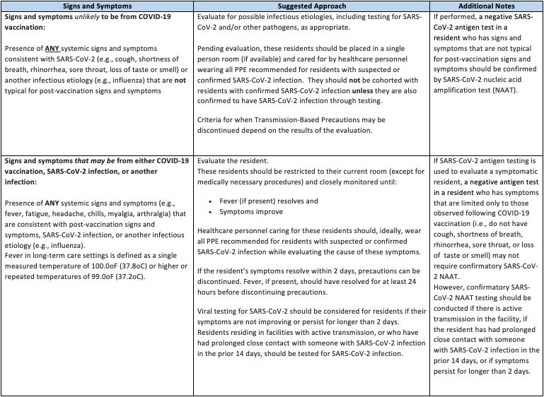

REFERENCES:
CDC (Updated 12/13/2020). Post Vaccine Considerations for Residents. https://www.cdc.gov/coronavirus/2019-ncov/hcp/post-vaccine-considerations-residents.html
CDC. What To Expect After Getting a Covid-19 Vaccine. https://www.cdc.gov/coronavirus/2019-ncov/vaccines/pdfs/321466-A_FS_What_Expect_COVID-19_Vax_Final_12.13.20.pdf
CDC (12/21/2020). Covid-19 Vaccination Communication Toolkit. https://www.cdc.gov/vaccines/covid-19/health-systems-communication-toolkit.html
CDC (Updated 3/5/2021). Interim Clinical Considerations for Use of Covid-19 Vaccines Currently Authorized in the United States. https://www.cdc.gov/vaccines/covid-19/info-by-product/clinical-considerations.html#Administration
NYSDOH (Effective 3/17/2021). Guidance for the NYS Covid Vaccination Program. https://coronavirus.health.ny.gov/system/files/documents/2021/03/guidance_for_facilities_receiving_vaccine.pdf
Moderna Vaccine EUA. https://www.modernatx.com/covid19vaccine-eua/providers/
Pfizer (12/2020). Fact Sheet for Healthcare Providers Administering Vaccines (Vaccination Providers). https://www.fda.gov/media/144413/download
Pfizer (12/2020). Fact Sheet for Recipients and Caregivers. https://www.fda.gov/media/144414/download
FDA (Rev 4/23/2021). EUA of Janssen Covid-19 Vaccine to Prevent Covid-19 in Individuals 18 Years of Age and Older. https://www.fda.gov/media/146305/download
NYSDOH DAL (4/19/2021). https://commerce.health.state.ny.us/HCSRestServices/HCSContentServices/docs?docPath=/hcs_Documents/Source/hpn/hpnSrc/C05AC5D9214C5A0AE0530547A8C08215.pdf
NYSDOH (5/3/2021). Covid-19 Policy for Predrawn Vaccine. https://coronavirus.health.ny.gov/system/files/documents/2021/05/predrawn-vaccine-policy_5-3-21.pdf
CMS (5/11/2021). Interim Final Rule – COVID-19 Vaccine Immunization Requirements for Residents and Staff. https://www.cms.gov/files/document/qso-21-19-nh.pdf
CDC (Updated 5/14/2021). Interim Clinical Considerations for Use of Covid-19 Vaccines Currently Authorized in the United States. Interim Clinical Considerations for Use of COVID-19 Vaccines | CDC
FDA (8/23/2021). Pfizer-BioNTech Covid-19 Vaccine Frequently Asked Questions. https://www.fda.gov/emergency-preparedness-and-response/mcm-legal-regulatory-and-policy-framework/pfizer-biontech-covid-19-vaccine-frequently-asked-questions
FDA (8/23/2021). Q&A for Comirnaty (Covid-19 Vaccine mRNA). https://www.fda.gov/vaccines-blood-biologics/qa-comirnaty-covid-19-vaccine-mrna
Pfizer (8/23/2021). Vaccination Information Fact Sheet for Recipients and Caregivers About Comirnaty (Covid-19 Vaccine, mRNA) and Pfizer-BioNTech Covid-19 Vaccine to Prevent Coronavirus Disease 2019 https://www.fda.gov/media/144414/download
Pfizer (8/23/2021). Fact Sheet for Healthcare Providers Administering Vaccines (Vaccination Providers). https://www.fda.gov/media/144413/download
CDC (Updated 9/30/2021). Who is eligible for a Covid-19 Vaccine Booster Shot? https://www.cdc.gov/coronavirus/2019-ncov/vaccines/booster-shot.html#FAQs

REVISED:
4/21/2021; 5/5/2021; 6/2/2021; 8/25/2021; 9/23/2021; 10/6/2021

