POLICY
Residents receiving parenteral/intravenous therapy will receive therapies safely, timely, and efficiently in accordance to Physician’s orders. Additionally, parenteral/intravenous lines will be maintained according to evidence-based best practices to maximally reduce the risk of infection associated with parenteral and intravenous catheters.

BACKGROUND
Parenteral fluid is the delivery of fluid or medication through and intravenous, subcutaneous, intramuscular, or mucosal route to maintain adequate hydration, restore and/or maintain fluid volume, reestablish lost electrolytes, or provide nutrition which includes Total Parenteral Nutrition (TPN) and Peripheral Parenteral Nutrition (PPN).

Intravenous (IV) catheters are placed to deliver fluids, medications, or blood products directly into the bloodstream to treat a condition. There are two types of intravenous lines. Peripheral IVs (See Fig 1) – inserted in a small vein (usually in the arm or hand) and is placed for short term use. Central Venous Catheters (see Figs 2 and 3) – inserted in a large vein in the neck, chest (ex: implanted port), groin, or arm (ex: Peripherally Inserted Central Catheter – PICC) and terminates in one of the great vessels (ex: superior vena cava); placed for longer durations (ex: weeks to months); also used for when medications are unsafe to administer into smaller peripheral veins.

RESPONSIBILITY
Physicians, nurse practitioners and registered nurses are responsible for accessing and assessing central venous catheters. Physicians, nurse practitioners, registered nurses, and licensed practical nurses are responsible for accessing and peripheral intravenous catheters.

GENERAL GUIDELINES
- Facility staff who manage infusion catheters will have training and demonstrate clinical competency in parenteral and intravenous catheter use, including
  - Indications for catheter use
  - Proper procedures for the insertion and maintenance of catheters
  - Documentation – nurses note indicating type of device in place, type of fluid/medication given, condition of the IV site, how the resident/patient tolerated the infusion; signature on the E-MAR for fluid/medication administration; signature on the E-TAR for dressing change.
  - Appropriate infection control measures to prevent catheter-related infections
- Staff may only insert catheter types for which they have adequate training and demonstrated skill
- Only Registered Nurses (RN) may access and care for centrally inserted catheters.
- Staff are not to perform venipunctures or assess for blood pressure on the arm where the PICC is inserted.
- Physician’s order must indicate name of drug/IV fluid, dosage, route, rate of infusion, frequency of administration, and duration.
- Staff to use a syringe ≥10mLs when flushing central venous access devices (rationale: a smaller syringe could cause excessive pressure on the catheter which may result in catheter rupture).
- Aseptic technique to be observed at all times when working with IV equipment
- All infusion equipment must be sterile when first opened. Equipment must remain aseptic and must be changed if they become contaminated.
- Total Parenteral Nutrition (TPN) must be administered via a central line, while Peripheral Parenteral Nutrition (PPN) may be administered via a peripheral line.
- Resident complaints of pain or other problems regarding the catheter or treatment must be investigated immediately and appropriate follow-up measures are to be initiated.
- Registered nurses will obtain a physician’s order for the removal of any peripheral or central IV catheter that is no longer essential (rationale: decreases the risk for infections and other complications)

MAINTENANCE OF INTRAVENOUS (IV) CATHETERS
- Dressing, exit site, and line to be assessed at least daily and/or with each administration.
  - Dressing is clean, dry and intact
  - Line is securely in place (without evidence that the line has been dislodged)
- Evaluate IV line for proper functioning (no difficulties withdrawing blood or flushing the line that might indicate obstruction).
- Evaluate for signs and symptoms of infection
  - Palpate site through the dressing to identify tenderness
  - Visually inspect if a transparent dressing is in place
  - Remove opaque dressing to allow for visual inspection of the exit site if there is tenderness on palpation
  - Exit site should be assessed for redness, swelling or purulent discharge
  - *For residents who are non-verbal and unable to express pain/discomfort, the RNS will assess and document the frequency to monitor the IV site. Physician will be notified, and specific order will be entered on Treatment record as indicated
- Dressing Change
  - Gauze dressings should be changed every 2 days and PRN
  - Transparent, semi-permeable dressings should be changed every 5-7 days and PRN
  - Replace transparent dressings on central venous catheters every 5-7 days, unless the dressing is loose or soiled.
  - Dressings that are damp, loosened, or visibly soiled should be replaced immediately
  - Ensure dressings are dated and initialed at time of dressing change
  - Gather all dressing supplies prior to dressing change
  - Perform hand hygiene before and after the dressing change
  - Wear clean non-sterile or sterile gloves

i. Resident with a centrally placed catheters will have dressing changed weekly and when soiled or wet under sterile technique utilizing the central line dressing kit by an RN.
j. Measurement of PICC line will be done with dressing change and documented on Treatment Record. MD will be notified of any tubing migration or change in site including redness, warmth or difficulty flushing.

- Accessing Lines
  - Cover open lumens with sterile end caps or needleless connectors when the IV catheter is not in use
  - To prevent contamination of the lumen, disinfect access ports or hubs (scrub the hub!)
    - Perform hand hygiene
    - Don clean gloves
    - Using alcohol impregnated pad, scrub hub for 10-15 seconds (generate friction by scrubbing in a twisting motion as if you were juicing an orange). Make sure you scrub the top of the hub as well, not just the sides
    - Allow the hub to dry. Prevent it from toughing anything while drying
    - Access the port only with sterile devices
  - Caps and needleless components should be changed whenever the administration sets are changed (unless specified by the manufacturer)
  - No more often than every 72 hours

- Maintaining Patency of central lines – flush protocol*
  - PICC lines
    - if not in use: 5mL of Heparin flush Q12hrs
    - when in use: SASH protocol – 5mL normal saline flush, followed by administration of fluid/medication, followed by 5mL normal saline flush, followed by 5mL heparin flush
  - Triple Lumen Catheters
    - When not in use: 5mL of Heparin flush everyone 24 hours
  - Tunneled Catheters
    - When in use: SASH protocol – 5mL normal saline flush, followed by administration of fluid/medication, followed by 5mL normal saline flush, followed by 5mL heparin flush
  - Implanted Ports
    - When not in use: 5mL heparin flush every 30 days
    - When in use: SASH protocol – 5mL normal saline flush, followed by administration of fluid/medication, followed by 5mL normal saline flush, followed by 5mL heparin flush
*As per Physician order
- Administration Sets
  - Group of supplies that are used to infuse medications and other treatments through an IV line (IV tubing, clamp, spikes, adaptors)
  - Change sets used for continuous infusions every 7 days, but no sooner than every 4 days
  - Change sets for intermittent infusions every 24 hours (daily)
  - Change lipid containing parenteral nutrition sets at least every 24 hours, when new bag is started, immediately upon suspected contamination, or when the integrity of the product or system has been compromised.

- Handling IV line during resident care
  - Front-line staff should take care to protect IV lines from dislodgement and contamination during resident care activities
  - IV lines should not be submerged in water
    - *Cover with waterproof material when assisting with bathing or showering
  - Care should be taken not to pull on the device when assisting with transfer or repositioning

PROCEDURE: Inserting a PIV
- Gather supplies
  - IV insertion kit (contains tourniquet, tape, alcohol prep pad, IV change label, transparent dressing)
  - Sterile over-the-needle catheter (BD InSyte Autoguard #22Ga or #24Ga)
  - IV extension tubing
  - Needless connector
  - Multiple 4x4 gauzes (for cleaning, if necessary or to use as part of a pressure dressing in case of failure to access vein)
  - 10-mL prefilled normal saline flush syringe
  - Gloves
- Wash hands with soap and water
- Identify resident and explain procedure
- Place supplies within reach
- Prime the IV extension set
- Select vein (if possible, on non-dominant hand). Avoid the antecubital fossa
- Apply tourniquet at least 6 inches above the selected site (rationale: to distend vein)
- Cleanse site with alcohol-impregnated wipe (scrub for at least 30 seconds using back and forth motion)
- Allow area to air dry for 30 seconds. Do not fan to dry skin. (rationale: this provides the necessary time for bacteriocidal activity)
- Using non-dominant hand, stretch the skin taut and stabilize the vein 4-5cm below the insertion site, taking care not to contaminate the point of insertion
- Holding the over-the-needle catheter between the thumb and middle fingers, with the bevel up at least 15-20°, pierce the skin directly over the vein until a flashback of blood is visible.
- Drop the angle of the catheter a few degrees and advance the catheter with the needle by a few millimeters to ensure that the tip of the catheter has passed into a vein.
- Using the index finger, advance the hub of the catheter fully into the vein, holding the needle steady.
- While stabilizing the needle and catheter with the dominant hand, release the tourniquet with the non-dominant hand. Occlude the vein above the insertion site with the index finger of the non-dominant hand to reduce bleeding after needle removal.
- Remove the stylet needle from the catheter and engage the needle safety device. Set aside for disposal in sharps container.
- Attach pre-primed IV extension set into the catheter hub
- Flush the IV to ensure patency
  - Assess for swelling, redness or leaking at the IV insertion site. Ask the resident if he/she feels any pain during the flushing
- Secure the PIV with dressing, date and initial

Fig 1
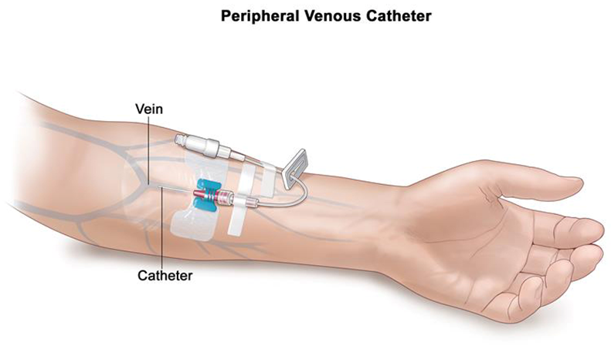

Fig 2
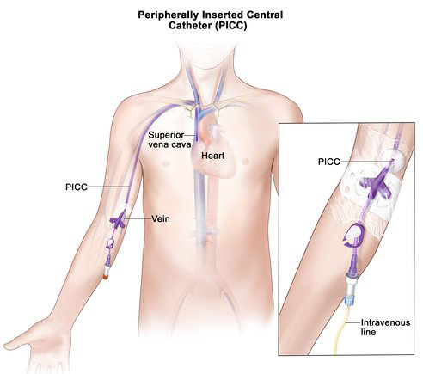

Fig 3
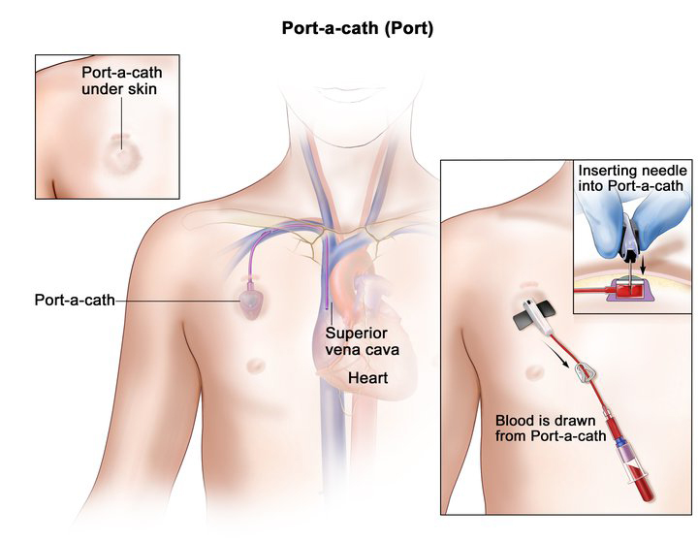

References

CDC Guideline for Prevention of Catheter Associated Bloodstream Infections, 2011. https://www.cdc.gov/infectioncontrol/guidelines/bsi/index.html

Ryder M., et al. Differences in bacterial transfer and fluid path colonization through needlefree connector-catheter systems in vitro. Paper presented at Society for Healthcare Epidemiology of America meeting, Dallas, Apr 29, 2011.

Sweet MA, et al. Impact of alcohol-impregnated port protectors and needleless neutral pressure connectors on central line–associated bloodstream infections and contamination of blood cultures in an inpatient oncology unit. Am J Infect
Control. 2012 Dec;40(10):931–934. doi: 10.1016/j.ajic.2012.01.025. Epub 2012 May

The Joint Commission. Preventing Central Line-Associated Bloodstream infections: Useful Tools, An International Perspective. Nov 20, 2013. http://www.jointcommission.org/CLABSIToolkit

Ball M., Singh A. Care of Central Line. Updated 5/18/2022. https://www.ncbi.nlm.nih.gov/books/NBK564398/

CMS (Rev 173, 11-22-17). State Operations Manual. F694: Parenteral Fluids, pp 376 – 380.

