SELF TESTING MADE EASY FOR COVID WITH i-HEALTH TEST
TESTING SUPPLIES:
- COLLECTION SWAB
- MIXING TUBE
- TEST CARD
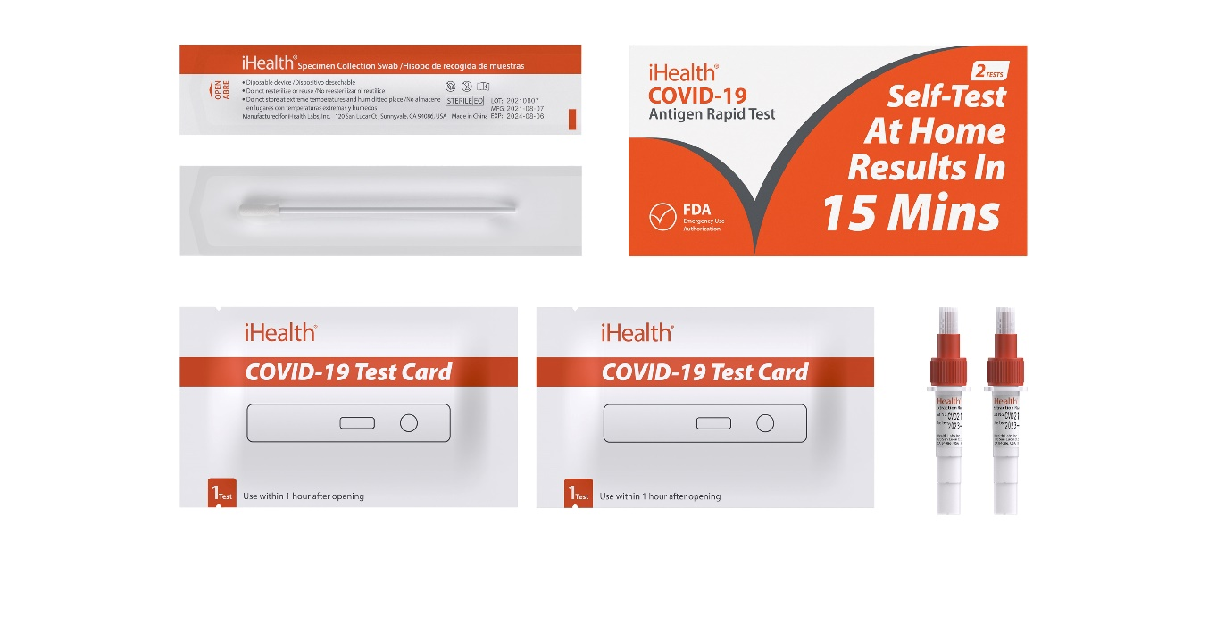
Figure 1 COLLECTION SWAB Figure 2 Test kit box Figure 3 TEST CARD Figure 4 Mixing Tube

STEP ONE: SWAB 5 times each nostril
Brush against the inner wall of both nostrils 5 times each in a circular motion with a non-invasive nasal swab. Our nasal swab is soft, highly absorbent, and only needs to be inserted ½ - ¾ inches so you can test yourself comfortably.
STEP TWO: DIP and STIR 15 times in mixing tube
Insert the swab with the sample into the bottom of the tube and stir it in the fluid 15 times. Squeeze the sides of the tube around the swab as you pull it out.
STEP THREE: DRIP X 3 ON TEST CARD (remove the clear plastic tip to allow the drips to come out)
Put 3 drops of the mixed solution onto the sample port of the COVID-19 test card.

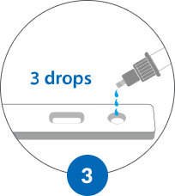

WAIT 15 MINUTES
Start the timer, or check your watch
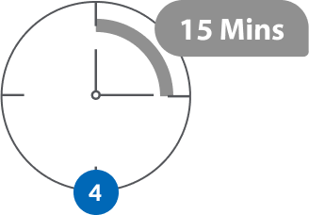
Negative result:
C T
POSITIVE RESULT:
C T
SHOW YOUR RESULTS TO THE RECEPTIONSIST
DISCARD ALL MATERIALS AND PERFORM HAND HYGIENE

