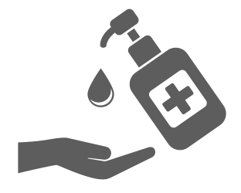
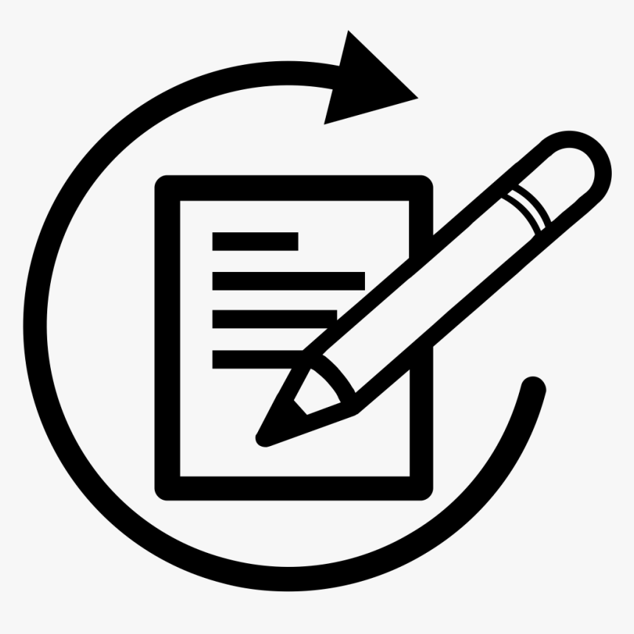

COVID-19 VISITOR GUIDANCE

VISITOR SAFETY FACT SHEET 1/13/2022

- All Visitors are required by NYSDOH to have a valid negative Covid test prior to visiting as of 1/12/2022
- All Visitors must follow the core principles and best practices to reduce the risk of Covid-19 transmission by:
  - performing hand hygiene upon entering the building and before leaving visitation area,
  - wearing a paper face mask or higher level mask to cover mouth and nose at all times when the county’s transmission rate is substantial to high
  - maintain physical distancing of at least 6 feet from residents, staff, and other visitors
- Upon entering the building, visitors are required to complete the Covid-19 questionnaire at the Kiosk (or on paper), and get a temperature screen
- Visitors are required to notify the facility (insert Department or contact person) if they experience any Covid-like symptoms or tests positive for Covid within 48 hours of the visit
- Visitors are not permitted to walk throughout the facility and must stay in the resident’s room or designated visiting area.
- While there is no limitation on the number of visitors a resident can receive, we respectfully ask that you limit the number of visitors in order to ensure social distancing rules are followed. If you would like to visit in a larger group, please contact (insert Department or contact person) so that appropriate accommodations can be made for you and your loved ones.
- The facility may need to make accommodations for visiting to ensure safety of the roommate when visiting in a multi-resident room
- While not recommended because of increased risk of getting Covid, residents who are on isolation precautions or quarantine can still receive visitors. Visits will be limited to the resident’s room. Facility requires all visitors to wear a mask and may require visitors to wear additional personal protective equipment (PPE) to include gown, gloves, mask, and eye protection.
- Visitors who are unable to adhere to facility’s protocols will not be permitted to visit and will be asked to leave

